Bussage School Uniform
Our children wear school uniform proudly to show and feel that they are part of the Bussage C of E Primary School family.
We encourage children to wear school uniform, they are expected to look smart and be dressed for the appropriate season and weather.
If you wish to purchase branded school uniform items with our school logo, they may be bought from Bateman’s Sports in Stroud: https://www.batemanssports.co.uk/schools-colleges/primary-schools/bussage
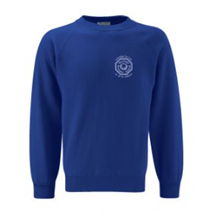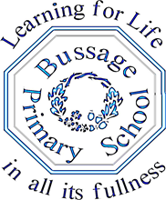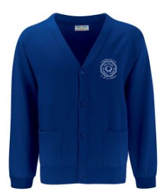
All other generic items can be sourced from shops, such as supermarkets, at low cost. There is no expectation for children’s general uniform items to be branded, however most children choose to wear our ‘Bussage Blue’ jumper or cardigan with our vision and logo on as it helps them to feel part of our school identity.
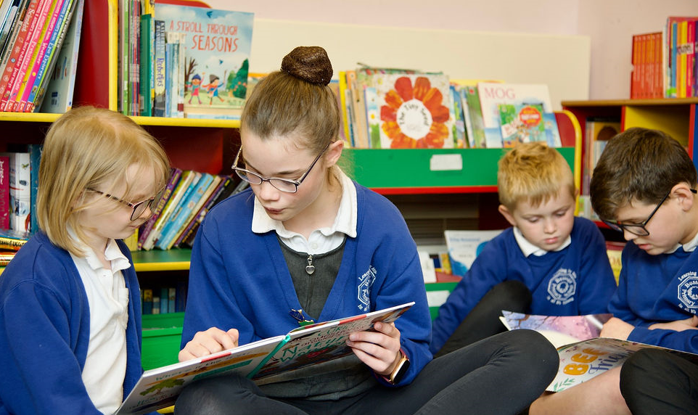
The PTA also hold a stock of second-hand uniform which is available to purchase for £1 per item with funds raised going to the PTA. To be able to access second hand uniform the PTA hold regular sales and can be contacted via their Facebook page.

The required uniform is:
- ‘Bussage Blue’ jumpers or cardigans
- White polo shirts or shirts/blouses
- Grey trousers, shorts, skirts or pinafores
- Blue gingham dresses / playsuits for summer
- Sensible footwear must be worn – black shoes or boots NOT trainers.
- Sandals with closed toes may be worn in the summer
For sporting activities:
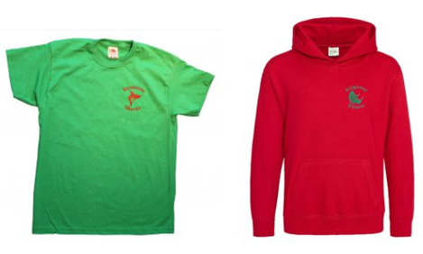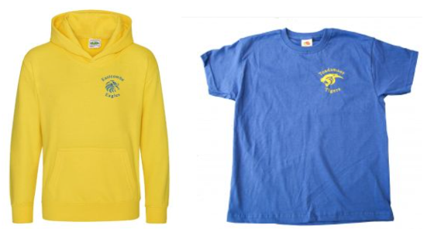
- A ‘house’ colour t shirt (branded ones available at Bateman’s Sports)
- Black or navy shorts/skort
- Trainers
- Black or navy jogging bottoms/leggings for winter outdoor sports

- A jumper/sweatshirt or hoody for winter outdoor sports (branded house team hoodies are available from Bateman’s Sports if you should wish)



